Investigate the Differences of Corticosterone Responses to Chronic Unpredictable Stress in Lean and Obese Mice

Abstract
Obesity and chronic stress are closely linked, but how pre-existing obesity alters physiological responses to chronic stress remains unclear. This study examined the effects of diet-induced obesity and chronic unpredictable stress (CUS) on metabolic, behavioral, hepatic, and corticosterone-related outcomes in male C57BL/6J mice. Mice were maintained on either a high-fat diet (HFD) or normal chow diet (NCD) for 12 weeks, followed by 21 days of CUS or control (CON) conditions. Body weight, food intake, body composition, open field behavior, liver histology, endpoint serum glucose, and 24-hour plasma corticosterone profiles were assessed. HFD successfully induced obesity prior to stress exposure. After stress initiation, CUS reduced body weight in both diet groups, with greater loss in HFD mice, primarily due to lean mass loss rather than fat mass loss, but in spite of synergistic effects of HFD and CUS on food intake. Both HFD and CUS independently increased anxiety-like behavior in the open field test, whereas liver pathology was driven mainly by diet. Serum glucose did not differ significantly by diet, stress, or their interaction. Mixed-effects cosinor modeling confirmed significant 24-hour corticosterone rhythmicity and showed that chronic stress significantly reduced corticosterone waveform shape, whereas diet alone did not. Stratified analyses indicated that this stress-related rhythmic disruption was more evident in NCD mice than in HFD mice. Together, these findings suggest that chronic stress in this model acts primarily as a catabolic and behavioral challenge, while its endocrine effects are expressed more through altered corticosterone rhythmicity than through a simple increase in corticosterone secretion. This work increases our understanding of chronic stress effects in the presence or absence of obesity.

Introduction
Obesity rates remain high in the past decades, affecting over one-third of U.S. adults (Engin, 2024); while stress levels are also increasing, with a majority of Americans reporting moderate to high stress (Tomiyama, 2018). Interestingly, there is a bidirectional relationship between obesity and stress. People experiencing chronic stress have 21% elevated obesity levels, while those who are obese tend to have 19% higher stress levels over time (Cuevas et al., 2019; Hochberg et al., 2025). This linkage demonstrates a strong connection between obesity and stress, which together contribute to adverse health outcomes, including cardiovascular disease, diabetes, and mental health disorders (Russell & Lightman, 2019). The hypothalamic-pituitary- adrenal (HPA) axis plays an important role in regulating the body’s stress response, with cortisol acting as the primary glucocorticoid in humans and corticosterone in rodents (Livingstone et al., 2000). Mouse models provide a valuable tool for studying this relationship, as they allow researchers to isolate physiological changes from societal stressors such as weight stigma (Buchenauer et al., 2009). By controlling for environmental and psychological factors, mouse models enable a more precise investigation of the biological mechanisms linking obesity, stress, and health outcomes. Obesity disrupts glucocorticoid levels in both humans and mice, leading to a hormonal dysregulation of stress reactivity (Incollingo Rodriguez et al., 2015). However, the specific effects of obesity on corticosterone levels under chronic stress conditions remain unclear. This gap limits our understanding of how obesity exacerbates stress-related disorders, making it essential to investigate these mechanisms further to improve diagnoses, prevention, and therapeutic approaches.
The goal is to understand how obesity alters the activity of the HPA axis under stress, further to improve treatments for stress-related metabolic diseases and target stress reduction therapies in obese populations, to improve people’s health and quality of life. Specifically, it is important to quantify corticosterone levels and characterize the physiological, metabolic, and behavioral responses to chronic unpredictable stress in lean and diet-induced obese male mice. Based on prior research, we hypothesize that diet-induced obese mice will demonstrate higher basal corticosterone levels and higher corticosterone responses compared to lean mice likely due to obesity-induced hyperactivation of the HPA axis (Teeple et al., 2023). Clarifying how obesity affects the regulation of the HPA axis under chronic stress conditions could reveal the mechanisms by which obesity exacerbates stress-related disorders, including cardiovascular disease, depression, and metabolic syndrome, and help identify new therapeutic strategies.

Methods
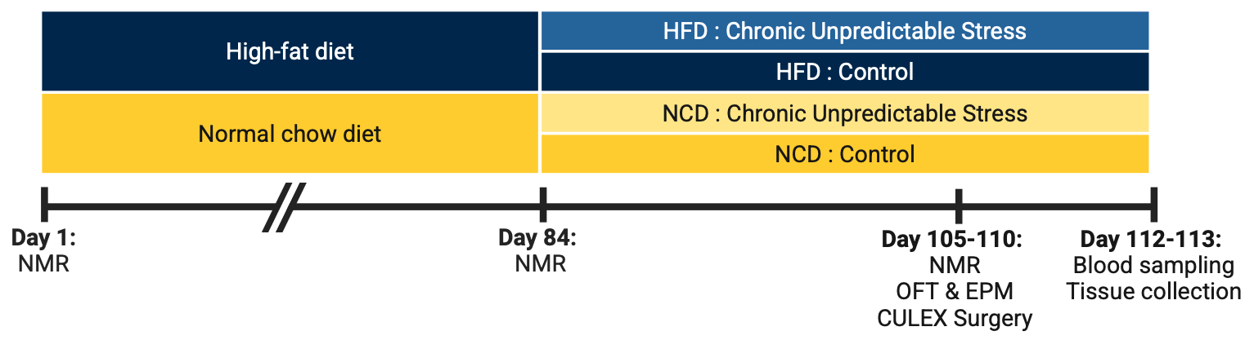
Figure 1. Experimental Design. Mice were maintained on either a high-fat diet (HFD) or normal chow diet (NCD) and subsequently assigned to chronic unpredictable stress (CUS) or control conditions. Nuclear magnetic resonance (NMR) was performed on Day 1 and Day 84 (week 12), followed by additional NMR, behavioral testing in the open field test (OFT) and elevated plus maze (EPM), and CULEX surgery on Days 105-110. Blood sampling and tissue collection were conducted on Days 112-113.

Animals and Experimental Procedures
Adult male C57BL/6J mice (RRID:IMSR_JAX:000664) were purchased from The Jackson Laboratory at 9 weeks of age. Mice were housed at 22°C under a 12:12-hour light/dark cycle. Following a 1-week acclimation period, animals were randomized into four experimental groups (n = 8 per group) based on diet and stress exposure (Figure 1). Mice were assigned to either a high-fat diet (HFD; D12492, 60 kcal% fat; Research Diets, Inc.) or a normal chow diet (NCD) for the duration of the study. Within each diet group, mice were further assigned to either chronic unpredictable stress (CUS) or undisturbed control conditions. Body weight was measured weekly beginning on the day of diet induction, and food intake was also recorded weekly. During the stress period, mice in the stress groups were singly housed to allow direct measurement of individual food intake. In contrast, mice in the control groups remained group housed; therefore, average food intake per control mouse was estimated by dividing the total grams of food consumed per cage over one week by the number of mice housed in that cage. At the experimental endpoint, mice were fasted for 4 hours in the morning, anesthetized with isoflurane, and terminal blood was collected by retro-orbital sampling for serum biochemical analysis. Mice were then euthanized by cervical dislocation, and liver, epididymal white adipose tissue (eWAT), and quadriceps muscle were rapidly dissected and collected. Liver samples intended for histological analysis were fixed in 10% phosphate-buffered formalin for 24 hours and then transferred to 70% ethanol until processing, whereas the remaining tissues were snap-frozen and stored at -80°C for later analysis. All animal procedures were approved by the University of Michigan Institutional Animal Care and Use Committee.

Chronic Unpredictable Stress
The chronic unpredictable stress (CUS) procedures were done as previously described, with slight modifications (Athanassi et al., 2023; Mao et al., 2023). ​​Stressors used before and after surgery for CULEX connections are summarized in Table 1. Before surgery, mice in the stress groups were exposed once daily to one of the following stressors: restraint (30 min), shaking (10 1-min cycles separated by 1-min intervals), tilted cage (45° for 1 h), tail suspension (5 min), forced swimming (5 min), or overnight illumination. To reduce consecutive exposure to higher-intensity stressors, selected pre-surgical stressors were categorized as moderate or mild. Moderate stressors, including restraint, tail suspension, and forced swimming, were not administered on consecutive days and were instead separated by 1-2 days of mild stressors, including shaking, tilted cage, or overnight illumination. After surgery, the stress schedule was limited to stressors compatible with the post-surgical setup, including overnight illumination, sound exposure (80 dB random noise for 20 min), and odor exposure (predator odor for 1 h). Unless otherwise specified, stressors were administered during the light phase (05:00-17:00, Eastern Standard Time; 06:00-18:00, Eastern Daylight Time), with one stressor applied per day in a randomized order to maintain unpredictability. Control mice were housed in a separate room and were not exposed to stress procedures or associated sensory cues.

Table 1. Chronic unpredictable stress (CUS) protocol used before and after surgery in male C57BL/6J mice. Mice were randomly exposed to one stressor per day to maintain unpredictability. The table lists all stressors administered during the pre-surgery and post-surgery phases, along with the materials used and their frequency or duration. Control mice were housed separately and were not exposed to any stressors.
Stressors before surgery | Materials | Frequency / Duration
Restraint | Restrainers | 30 minutes
Shaking | Shaker, elastic bands | 10 times, 1 minute each, 1 minute apart
Tilted cage | Mice in their homecage, long mouse cages put into 45-degree angle | 1 hour
Tail suspension | Square-shape box with two cylinders taped on the top, white ULAM Tape, blue pads | 5 minutes
Forced swimming | Mice placed in a clear glass beaker with 24℃ water | 5 minutes
Overnight illumination | Mice exposed to regular room light | 24 hours including light hours
Stressors after surgery | Materials | Frequency / Duration
Sound exposure | Mice exposed to noise from a radio at 80 dB | 20 minutes
Overnight illumination | Mice exposed to regular room light | 24 hours including light hours
Odor | Mice in their homecage placed with a piece of cotton pad with coyote urine | 1 hour

Body Composition
Body compositions were analyzed using EchoMRI 3 in 1 (EchoMRI, Houston, TX, USA). The EchoMRI emits radio pulses that result in hydrogen proton spins releasing radio signals that differentiates fat, lean, and free water based on specific radio pulse signals. This measurement was performed three times, once at the beginning of diet intervention, once at the beginning of stress exposure, and once at the end of stress exposure. All body composition measurements were done by the University of Michigan MMPC-Live Core.

Estimated Energy Expenditure
Estimated energy expenditure was derived indirectly from energy intake and changes in body composition rather than measured directly by calorimetry. For each mouse, changes in fat mass and lean mass over the analysis period were calculated from serial EchoMRI measurements, converted to energy equivalents using 9.1 kcal/g for fat mass and 4.2 kcal/g for lean mass, and summed to estimate total energy stored in tissue during that interval (Ravussin et al., 2013). This value was then divided by the number of days in the interval to estimate daily energy stored. Average daily caloric intake over the same interval was calculated from food intake records, and estimated daily energy expenditure was approximated as daily caloric intake minus daily energy stored in tissue, providing an indirect estimate of whole-body energy balance.

Behavior Tests
All of the behavioral tests were done during the light phase (05:00-17:00, Eastern Standard Time; 06:00-18:00, Eastern Daylight Time).

Open Field Test
The Open Field Test (OFT) was performed to assess general locomotor activity, exploratory behavior, and anxiety-like responses in mice (Mao et al., 2023). The apparatus consisted of a square white arena (45 x 45 cm) divided into three concentric zones: a center zone (21 x 21 cm), an intermediate zone (30 x 30 cm), and an outer zone (45 x 45 cm). Mice were transferred to the behavioral testing room at least one hour prior to testing for acclimation. Four arenas were positioned on elevated tables under uniform illumination (40 lux). Each mouse was placed individually in the top-left corner of the arena and allowed to freely explore for 30 minutes. Animal movement was recorded and automatically tracked using EthoVision XT software (Noldus Information Technology) with center-point, nose-point, and tail-base detection. Parameters analyzed included total distance traveled, velocity, time spent in each zone, number of center-zone entries, and frequency of rearing behavior. The arena was cleaned thoroughly with 70% ethanol between trials to remove odor cues.

Elevated Plus Maze test
The Elevated Plus Maze (EPM) was used to assess anxiety-like behavior in mice by measuring the natural conflict between exploration of novel environments and avoidance of open, elevated spaces (Mao et al., 2023). The apparatus consisted of a plus-shaped maze elevated 50 cm above the floor, with two open arms (30 x 6 cm), two closed arms (30 x 6 cm) enclosed by 15-cm-high opaque walls, and a central platform (6 x 6 cm). Mice were transferred to the behavioral testing room at least one hour prior to testing to acclimate. During testing, each mouse was placed individually on the center platform facing one of the open arms and allowed to freely explore the maze for 5 minutes. Behavior was video recorded and automatically tracked using EthoVision XT software (Noldus Information Technology) with center-point, nose-point, and tail-base detection. Parameters analyzed included the time spent in and number of entries into the open and closed arms, time spent in the center zone, total distance traveled, and frequency of rearing behaviors. The maze was thoroughly cleaned with 70% ethanol between trials to remove olfactory cues.

Carotid Artery Cannulations
Mice were anesthetized with isoflurane, and carotid artery cannulation was performed under aseptic conditions by the University of Michigan MMPC-Live Core. The right carotid artery was isolated through a ventral neck incision, and a catheter bevel was advanced into the aortic arch without contacting the aortic valve. The catheter was secured to the vessel with sutures, tunneled subcutaneously, and exteriorized at the back of the neck, where it was connected to the arterial port of a stainless steel tubing connector fixed subcutaneously during skin closure. After surgery, the cannula was flushed daily with saline and sealed with heparin-saline. Cannulated mice were housed individually and weighed daily.

Automated Blood Sampling
Following surgery, mice were acclimated for 5 days to Raturn cages as part of the Culex automated blood sampling system (BASi, Inc.). After acclimation, serial blood samples were collected from the carotid cannula at 1-hour intervals over a 24-hour period (Sáenz De Miera et al., 2023). To account for the dead volume in the cannula and tubing, 55 μL of whole blood was withdrawn at each time point. Of this volume, 10 μL was diluted with 50 μL of heparinized saline in refrigerated glass tubes, and the remaining 45 μL of blood, together with 10 μL of heparinized saline, was returned to the mouse to maintain blood volume. All automated blood sampling procedures were performed by the University of Michigan MMPC-Live Core.

Plasma Corticosterone
Plasma corticosterone concentrations were measured using a competitive ELISA kit (Corticosterone ELISA Kit, Item No. 501320; Cayman Chemical, Ann Arbor, MI, USA) according to the manufacturer’s instructions. Absorbance was read at 405 nm, and corticosterone concentrations were calculated from the standard curve generated in each assay.

Serum Glucose and Insulin
Serum glucose concentrations were measured using a colorimetric assay (FujiFilm Autokit Glucose, Cat. 997-03001) according to the manufacturer’s instructions. Serum samples and standards were assayed in duplicate, and absorbance was measured at 505 and 600 nm. Glucose concentrations were determined from the standard curve.
Serum insulin concentrations were measured using a mouse insulin ELISA kit (Abnova Insulin (Mouse) ELISA Kit, Cat. KA3812) according to the manufacturer’s instructions. This sandwich ELISA was performed in duplicate, and absorbance was read at 450 nm. Insulin concentrations were calculated from the standard curve.

Liver Histology
Liver tissues were fixed in 10% phosphate-buffered formalin for 24 hours and subsequently stored in 70% ethanol until further processing by the Tissue and Molecular Pathology Core at the Rogel Cancer Center (Harvey et al., 2018). Samples were dehydrated, embedded in paraffin, sectioned, and stained with hematoxylin and eosin (H&E) to evaluate liver morphology. Stained sections were imaged using a 20x objective of an Olympus IX81 microscope and software cellSens.
Liver sections were evaluated for nonalcoholic fatty liver disease activity score (NAS) and inflammatory foci. NAS was assessed based on steatosis, lobular inflammation, and hepatocellular ballooning, as described previously in rodent histologic scoring systems (B.-K. Jeong et al., 2024; Karimkhanloo et al., 2023; Liang et al., 2014; X.-J. Liu et al., 2018; Yang et al., 2023). For inflammatory foci quantification, an inflammatory focus was defined as a cluster of approximately 10-12 mononuclear cells (Selvarani et al., 2025). One liver section per mouse was analyzed, and five images were captured from each section using a 20x objective. Inflammatory foci were manually counted in each image in a blinded fashion.

Statistical analyses
All statistical analyses were conducted in R (version 4.4.2; R Core Team, 2024). Mixed linear models were fitted using the lme4 package (version 1.1.37; Bates et al., 2015). Statistical significance was defined as p < 0.05.
For repeated longitudinal outcomes, including body weight, fat mass, lean mass, and food intake, mixed linear models with random intercepts and random slopes for time were used to account for within-mouse correlation across repeated measurements.
During the pre-stress period, each outcome was modeled as a function of diet, time, and the diet x time interaction. The coefficient for time was used to estimate the rate of change over time within each diet group, and the diet x time interaction term was used to test whether the rate of change differed between HFD and NCD mice.
During the post-stress period, analyses were performed in two stages. First, within each diet group, stratified mixed-effects models including stress, time, and the stress x time interaction were used to determine whether chronic unpredictable stress altered the trajectory of each outcome over time. Second, to evaluate whether the effect of stress over time differed by diet, we fit an overall mixed linear model including diet, stress, time, and their interaction terms, where the three-way interaction term was used to assess whether stress-related changes over time differed between diet groups. Unless otherwise indicated, final mixed-effects models retained the diet x stress interaction term.
For endpoint outcomes measured once per mouse, including serum glucose and estimated energy expenditure, standard linear models were used to test the main effects of diet and stress and their interaction. For liver histology outcomes, models included diet, stress, and diet x stress as fixed effects; mixed-effects models with a random intercept for mouse were used when multiple observations per mouse were analyzed. Behavioral outcomes from the open field test were analyzed using mixed-effects models including diet, stress, trial/time, and the relevant interaction terms, consistent with the repeated-measures structure of the data. This modeling strategy was used because several behavioral measures changed across the course of testing, including center-zone duration, center-zone frequency, and center-intermediate-zone duration.
For plasma corticosterone measured repeatedly over 24 hours, analyses were performed via two approaches. We first used mixed-effects cosinor models to assess 24-hour rhythmicity and to test whether diet, chronic unpredictable stress, or their interaction altered corticosterone waveform shape. Zeitgeber time was represented using sine and cosine transformations of the 24-hour cycle, and mouse ID was included as a random effect to account for repeated samples within each mouse. Overall rhythmicity was assessed by joint hypothesis testing of the sine and cosine terms, and diet-, stress-, and diet x stress-related waveform effects were evaluated by joint tests of the corresponding interaction terms. Stratified cosinor analyses were performed within diet groups to determine whether the effect of stress on corticosterone rhythmicity differed between NCD and HFD mice. In the second approach, corticosterone summary parameters were calculated from the observed 24-hour corticosterone profiles and analyzed to help interpret waveform differences: mesor was defined as the arithmetic mean corticosterone concentration across the 24-hour sampling period; peak as the maximum observed concentration; nadir as the minimum observed concentration; amplitude as half the difference between peak and nadir; and acrophase as the observed timing of peak corticosterone concentration within the 24-hour cycle. The 24-hour area under the curve (AUC) was also calculated as a summary measure of overall corticosterone exposure. Group differences in these parameters were assessed using Kruskal-Wallis tests, pairwise comparisons, and gamma generalized linear models (GLMs) due to the skewed nature of corticosterone measurements. Pairwise comparisons of interest included HFD-CUS vs. HFD-CON, NCD-CUS vs. NCD-CON, HFD-CUS vs. NCD-CUS, and HFD-CON vs. NCD-CON.

Results

Changes in weight, body composition, and food intake
To determine how diet influences body weight and body composition over time, we randomly assigned male C57BL/6J mice to either HFD or NCD and monitored their body weights weekly throughout the 12-week pre-stress period. Body composition (fat and lean mass) and food intake were also assessed to characterize metabolic changes associated with diet exposure.
Prior to stress, body weights, fat mass, and lean mass were significantly increased by HFD over time compared to NCD. Table 2 describes the modelled rates of body weight, fat and lean mass accretion during this phase. By the end of the 12-week pre-stress period, HFD mice averaged 47.5 ± 1.14 grams, and NCD mice averaged 32.0 ± 1.39 grams (p < 0.001, Figure 2A). In terms of body composition, HFD mice averaged 16.3 ± 0.87 grams (34.3 ± 1.49%) of fat mass prior to stress initiation, while NCD mice averaged 2.40 ± 1.07 grams of fat mass (7.71 ± 1.83%) (p < 0.001, Figure 2B). Comparing lean mass, HFD mice averaged 29.0 ± 0.47 grams (63.3 ± 1.37%) and NCD mice had 27.7 ± 0.57 grams lean mass (87.5 ± 1.68%) (p = 0.09, Figure 2C). These results indicate that after 12 weeks of dietary induction, HFD mice exhibited markedly greater overall weight and fat mass gains compared to NCD controls, confirming the successful establishment of the obese phenotype prior to stress exposure. To confirm baseline balance between groups, we compared body weight, fat mass, and lean mass between mice randomized to CUS versus control using estimated marginal means from the mixed-effects model (emmeans), and no significant differences were detected (p > 0.05).
This weight gain was primarily driven by differences in caloric intake. Throughout the 12-week pre-stress period, HFD-fed mice consistently consumed more kilocalories per day than NCD-fed mice, regardless of stress (Figure 2D). Estimated marginal means from the mixed-effects model indicated that HFD mice consumed an average of 27.0 kcal/day, whereas NCD mice consumed 14.6 kcal/day (p < 0.01).

Table 2. Effects of diet on daily changes in body weight, fat mass, lean mass, and food intake of male C57BL/6J mice during the pre-stress period. Data were analyzed using linear mixed-effects models to evaluate the main effects of diet, time, and their interaction. Fixed-effect estimates (mean ± SE) and p-values are reported for each term. HFD: High-Fat Diet, NCD: Normal Chow Diet, CUS: Chronic Unpredictable Stress, CON: Control. The interaction between Diet and Stress is denoted as p_{int.}
 | Diet | Rate of change (g/day) | p-value | p_{int}
Body weight | NCD | 0.0536 ± 0.0044 | p < 0.001 | p < 0.001
 | HFD | 0.2439 ± 0.0167 | p < 0.001 | —
Fat mass | NCD | 0.0088 ± 0.0025 | p < 0.005 | p < 0.001
 | HFD | 0.1829 ± 0.0138 | p < 0.001 | —
Lean mass | NCD | 0.0421 ± 0.0062 | p < 0.001 | p < 0.01
 | HFD | 0.0689 ± 0.0051 | p < 0.001 | —
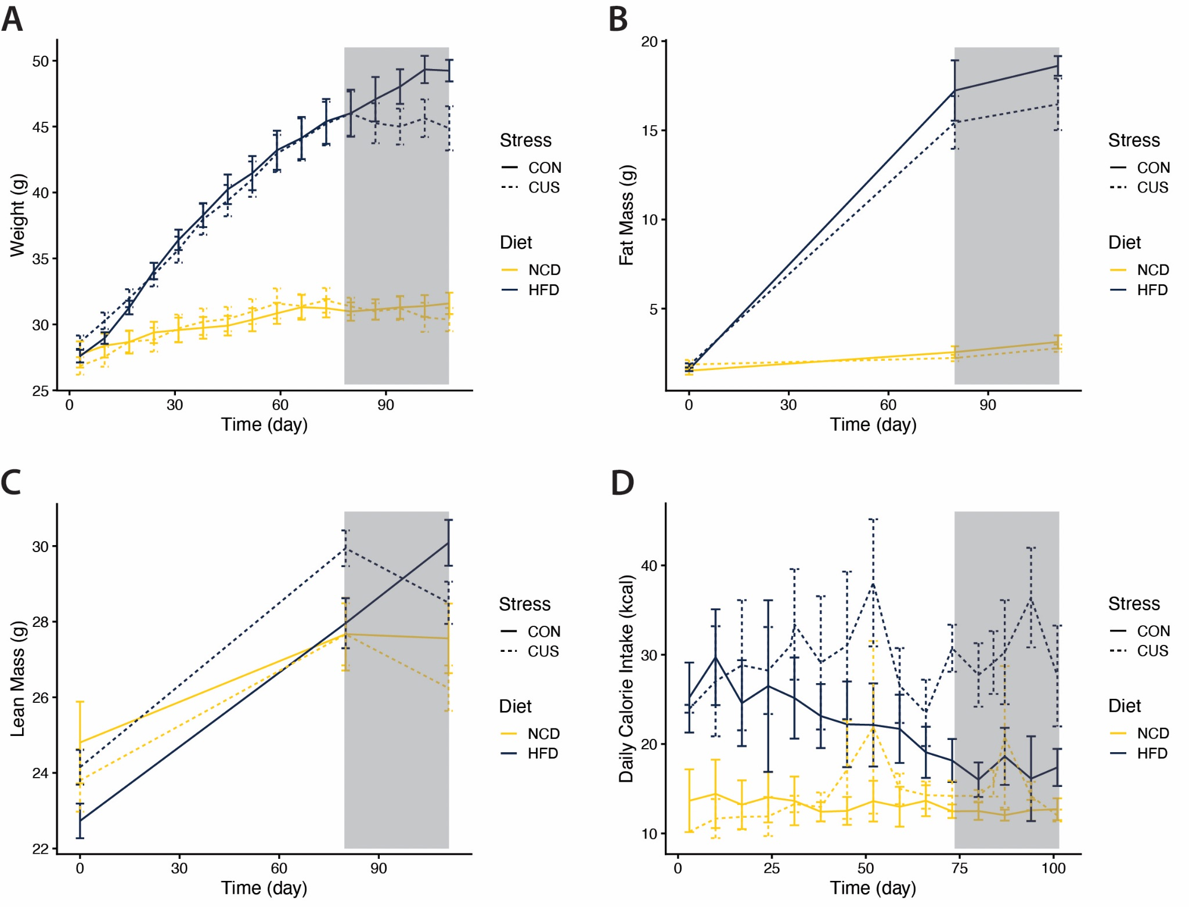
Figure 2. Effect of diet on body weight, body composition (fat mass, lean mass), daily calorie intake over 16 weeks in mice exposed to diet-induced obesity and chronic unpredictable stress (initiated on Day 84, shaded area). A. Body weights in grams. B. Fat mass in grams. C. Lean mass in grams. D. Calorie intake in kilocalories. HFD: High-Fat Diet, NCD: Normal Chow Diet, CUS: Chronic Unpredictable Stress, CON: Control. Data are plotted as group means with SEM error bars.

Chronic unpredictable stress decreased body weight via lean mass after diet-induced obesity was established
To evaluate how chronic unpredictable stress influences metabolic outcomes after obesity was induced, we exposed the mice that had completed 12 weeks of dietary induction (HFD or NCD) to a 21-day chronic unpredictable stress (CUS) protocol or control (CON) conditions. Similarly, body weights and food intake were measured weekly throughout the stress period, and body composition (fat and lean mass) was assessed at the beginning and the end of the protocol. These measurements were used to determine how stress interacts with diet to alter weight trajectory and body composition following the establishment of diet-induced obesity. Table 3 describes the modelled rates of body weight, fat and lean mass changes due to stress induction during this phase.
Therefore, we asked whether stress changed body weight over time. Figure 3A and 3B showed that, in NCD mice, the body weights decreased 0.06 ± 0.025 grams each day (p < 0.01); and in HFD mice, their body weights decreased 0.10 ± 0.03 grams each day (p < 0.005). These effects of chronic unpredictable stress on weight loss were augmented by HFD (p < 0.005). Therefore, we asked whether the change in body weight is related to the change in fat mass or lean mass.
Across the 21-day stress period, fat mass did not change significantly in either diet group (Figure 3C and 3D). In NCD mice, fat mass decreased by 0.0006 ± 0.01 g per day (ns), and in HFD mice, fat mass decreased by 0.04 ± 0.05 g per day (ns), indicating that stress-induced weight loss was not attributable to reductions in adiposity. In contrast, stress induction led to significant losses of lean mass (Figure 3E and 3F). NCD mice lost lean mass at a rate of 0.04 ± 0.01 g per day (p < 0.005), while HFD mice experienced a substantially greater stress-induced decline of 0.11 ± 0.015 g per day (p < 0.001). A significant diet x time interaction (p < 0.001) confirmed that chronic unpredictable stress produced disproportionately larger lean mass losses in HFD mice compared with NCD mice.
We then asked whether changes in body weight and body composition were associated with food intake. As shown in Figure 3G and 3H, both high-fat diet and chronic unpredictable stress were associated with higher caloric intake during the stress period. In the mixed-effects model, chronic unpredictable stress was associated with an increase of 10.26 ± 4.32 kcal/day (p < 0.05), while high-fat diet was associated with an increase of 11.93 ± 4.10 kcal/day (p < 0.05). In stratified analyses, the stress-associated increase in caloric intake was larger in HFD mice (13.77 ± 6.42 kcal/day, p = 0.051) than in NCD mice (3.49 ± 4.10 kcal/day, ns). Thus, stress did not reduce food intake; rather, both diet and stress contributed to higher calorie consumption during the stress period, with the greatest intake observed in mice exposed to both HFD and CUS. These findings indicate that the reductions in body weight and lean mass following stress were not explained by decreased caloric intake.
As the reductions in body weight and lean mass during the stress period were not explained by decreases in food intake or fat mass, we next examined estimated energy expenditure to evaluate whether changes in energy balance contributed to these observations.
Estimated energy expenditure was derived from daily caloric intake and changes in fat and lean mass across the stress period, was then examined to assess whether altered energy balance contributed to the observed weight loss. A significant synergistic interaction was found between diet and stress (p < 0.05), indicating that the effect of stress on energy expenditure differed between diet groups with a larger effect in HFD mice (Figure 3I). Stratified analyses showed that chronic unpredictable stress significantly increased estimated energy expenditure in HFD-fed mice (p < 0.01), whereas no significant change was observed in mice maintained on normal chow (p = 0.19). These findings suggest that stress exposure may alter energy balance in obese mice, potentially contributing to greater weight and lean mass losses observed in the HFD group during the stress period.

Table 3. Effects of stress on daily changes in body weight, fat mass, lean mass, and food intake of male C57BL/6J mice in different diets (HFD, NCD) during the stress period. Data were analyzed using linear mixed-effects models to evaluate the main effects of diet, stress, and time, as well as their two-way and three-way interaction terms. Fixed-effect estimates (mean ± SE) represent the rate of change (grams per day) within each experimental group, and p-values correspond to the significance of the main and interaction effects for each outcome. HFD: High-Fat Diet, NCD: Normal Chow Diet, CUS: Chronic Unpredictable Stress, CON: Control.
 | Diet | Rate of change (g/day) | p-value | p_{int}
Body weight | NCD | -0.058 ± 0.025 | p < 0.05 | ns
 | HFD | -0.099 ± 0.033 | p < 0.005 | —
Fat mass | NCD | -0.001 ± 0.013 | ns | ns
 | HFD | -0.041 ± 0.054 | ns | —
Lean mass | NCD | -0.042 ± 0.011 | p < 0.005 | p < 0.001
 | HFD | -0.1115 ± 0.015 | p < 0.001 | —
Food intake | NCD | -0.4407 ± 0.642 | ns | ns
 | HFD | -0.1010 ± 0.692 | ns
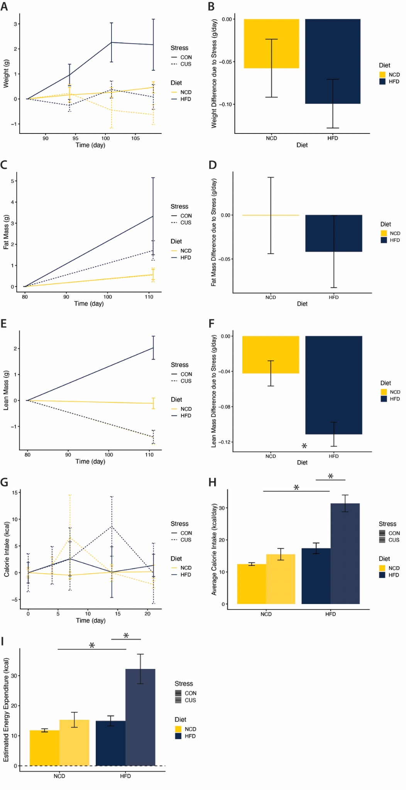
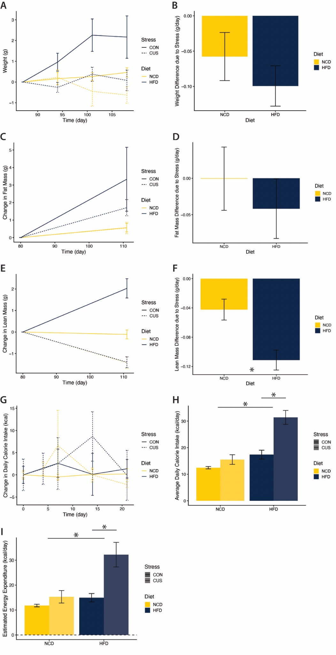
Figure 3. Effect of stress and diet on body weights, body composition (fat mass, lean mass), and calorie intake over 21-day stress induction in mice exposed to diet-induced obesity and chronic unpredictable stress. A. Body weights in grams. B. Differences in weight-change slopes among groups. Bars represent the estimated difference in daily weight-change rate. C. Fat mass in grams. D. Differences in fat mass-change slopes among groups. Bars represent the estimated difference in daily fat mass-change rate. E. Lean mass in grams. F. Differences in lean mass-change slopes among groups. Bars represent the estimated difference in daily lean mass-change rate. G. Calorie intake changes in kilocalories. H. Differences in average daily calorie intake among groups. I. Differences in daily estimated energy expenditure over stress period among groups. HFD: High-Fat Diet, NCD: Normal Chow Diet, CUS: Chronic Unpredictable Stress, CON: Control. Data are plotted as group means with SEM error bars. Asterisks indicate a significant effect of diet (HFD vs. NCD) or chronic unpredictable stress from the corresponding regression model.

High-fat diet and chronic unpredictable stress independently increased open-field anxiety-like behaviors
To investigate the effects of a high-fat diet and chronic unpredictable stress on behavior, we assessed anxiety-like behaviors using the Open Field Test (OFT) and the Elevated Plus Maze test (EPM). These assays allowed us to quantify exploratory activity and avoidance behavior in response to diet-induced obesity, stress exposure, and their potential interaction. We first asked whether diet and stress altered the amount of time mice spent in the center zone.
Figure 4A showed that mice exposed to chronic unpredictable stress spent 6.92 ± 2.71 fewer seconds in the center zone compared with controls (p < 0.05), and mice fed a high-fat diet spent 10.74 ± 2.74 fewer seconds in the center zone compared with NCD mice (p < 0.001). Over the course of testing, mice spent progressively more time in the center zone, with center duration increasing by 0.41 ± 0.11 seconds per trial (p < 0.001). Therefore, we asked whether diet modified the amount of time spent in the center zone as the trial progressed. A significant diet x time interaction was observed, indicating that HFD reduced the change in center-zone duration over time by 0.63 ± 0.31 seconds relative to NCD mice (p < 0.05). In contrast, stress did not significantly modify the change in center-zone duration across the trial (-0.14 ± 0.34, p = 0.67).
Another way to consider behavior in the open field test is to ask whether diet and stress influenced the number of entries into the center zone. As shown in Figure 4B, HFD reduced center entries by 5.05 ± 1.12 entries (p < 0.001), and chronic unpredictable stress reduced center entries by 2.29 ± 1.11 entries (p < 0.05). However, no significant interaction effects of diet or stress with time, and no diet x stress interaction, were observed for this measurement.
Because the arena used also included an intermediate zone, we next asked whether diet and stress affected time spent in the combined center and intermediate zone. Figure 4C showed that HFD mice spent 28.7 ± 8.16 fewer seconds in this area than NCD mice (p < 0.01), while stressed mice spent 23.0 ± 8.07 fewer seconds in these zones than controls (p < 0.01). Mice also increased their time in the combined center and intermediate zones over the course of testing by 1.10 ± 0.25 seconds per trial (p < 0.001). However, no significant interaction effects were observed for this outcome. We also asked whether diet and stress altered overall locomotor activity during the OFT, as measured by total distance traveled (Figure 4D). However, no significant main effects of diet or stress, and no significant interaction effects, were observed for total distance traveled. Therefore, the reductions in center-zone exploration observed in HFD and stressed mice were not accompanied by detectable differences in overall locomotor activity. Consistent with this, exploratory mediation analyses did not identify a significant indirect effect of body weight on the association between diet and center-zone duration, and showed only a non-significant trend for center-zone frequency, suggesting that reduced center-zone exploration in HFD mice was not fully explained by greater body weight alone. Together, these findings support the interpretation that both high-fat diet and chronic unpredictable stress independently promoted anxiety-like behavior.
To further assess anxiety-like behavior, mice were also evaluated using the Elevated Plus Maze (EPM). In contrast to the OFT, no significant main effects of diet or stress, and no significant interaction effects, were observed for EPM measurements (Supplemental Figure 1).
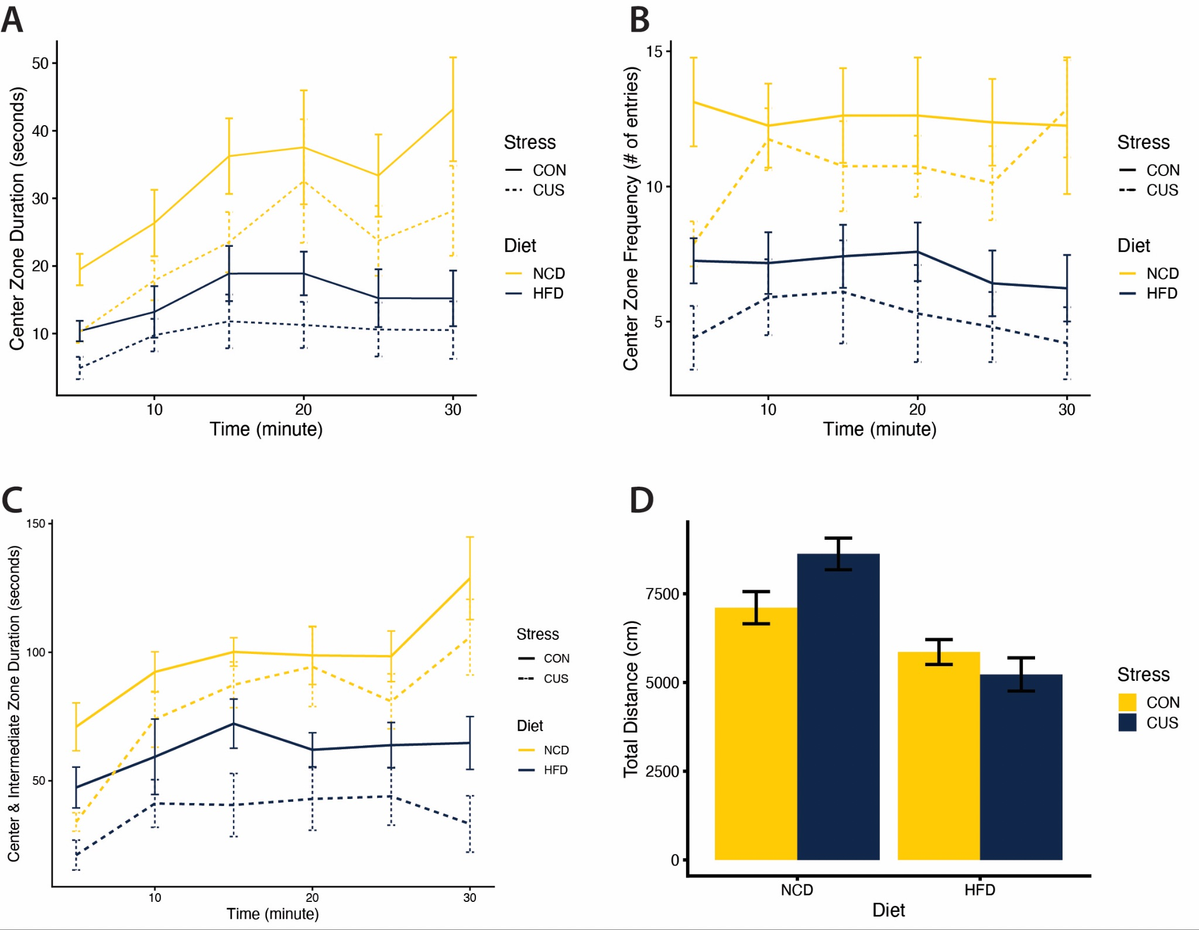
Figure 4. Effect of diet and stress on anxiety-like behavior measured by the Open Field Test.
A. Time spent in the center zone (seconds) across trials. B. Frequency of entries into the center zone (# of entries) across trials. C. Time spent in the center and intermediate zones (seconds) across trials. D. Total distance traveled during the Open Field Test (cm). HFD: High-Fat Diet, NCD: Normal Chow Diet, CUS: Chronic Unpredictable Stress, CON: Control. Data are plotted as group means with SEM error bars.

High-fat diet increased liver pathology
To determine whether diet-induced obesity and chronic unpredictable stress altered liver morphology, we evaluated liver sections stained with hematoxylin and eosin (H&E) and quantified histological injury using the NAFLD Activity Score (NAS). Representative liver sections are shown in Figure 5A. Livers from mice fed a high-fat diet exhibited greater lipid accumulation and altered hepatic architecture compared with mice maintained on normal chow. We first asked whether diet and stress affected overall liver pathology, as assessed by total NAS score. As shown in Figure 5B, NAS scores were significantly higher in mice fed a high-fat diet compared with mice maintained on normal chow (2.60 ± 0.54 points, p < 0.001), indicating increased hepatic pathology associated with diet-induced obesity. However, chronic unpredictable stress did not significantly affect NAS scores, and no significant diet x stress interaction was observed.
For a more specific quantification of histology, we determined which histological features contributed to the elevated NAS score in the HFD mice. As shown in Figure 5C, steatosis scores were significantly increased in HFD mice (increased by 1.45 ± 0.32 points, p < 0.001), whereas stress exposure did not significantly alter steatosis, and no significant diet x stress interaction was detected. Similarly, hepatocellular ballooning was elevated in HFD mice (0.55 ± 0.25, p < 0.05), while stress exposure did not significantly affect ballooning and no significant interaction effect was observed. Inflammation scores were also higher in HFD mice (0.55 ± 0.35, p < 0.05), but were not significantly altered by stress, with no significant diet x stress interaction.
We also asked whether diet and stress altered inflammation foci counts. As shown in Figure 5F, no significant main effects of diet or stress, and no significant diet x stress interaction were detected for inflammation foci counts. Therefore, although HFD increased overall liver pathology and significantly elevated steatosis, inflammation score, and ballooning, neither chronic unpredictable stress nor the diet-stress effect significantly altered inflammatory foci counts in this cohort.
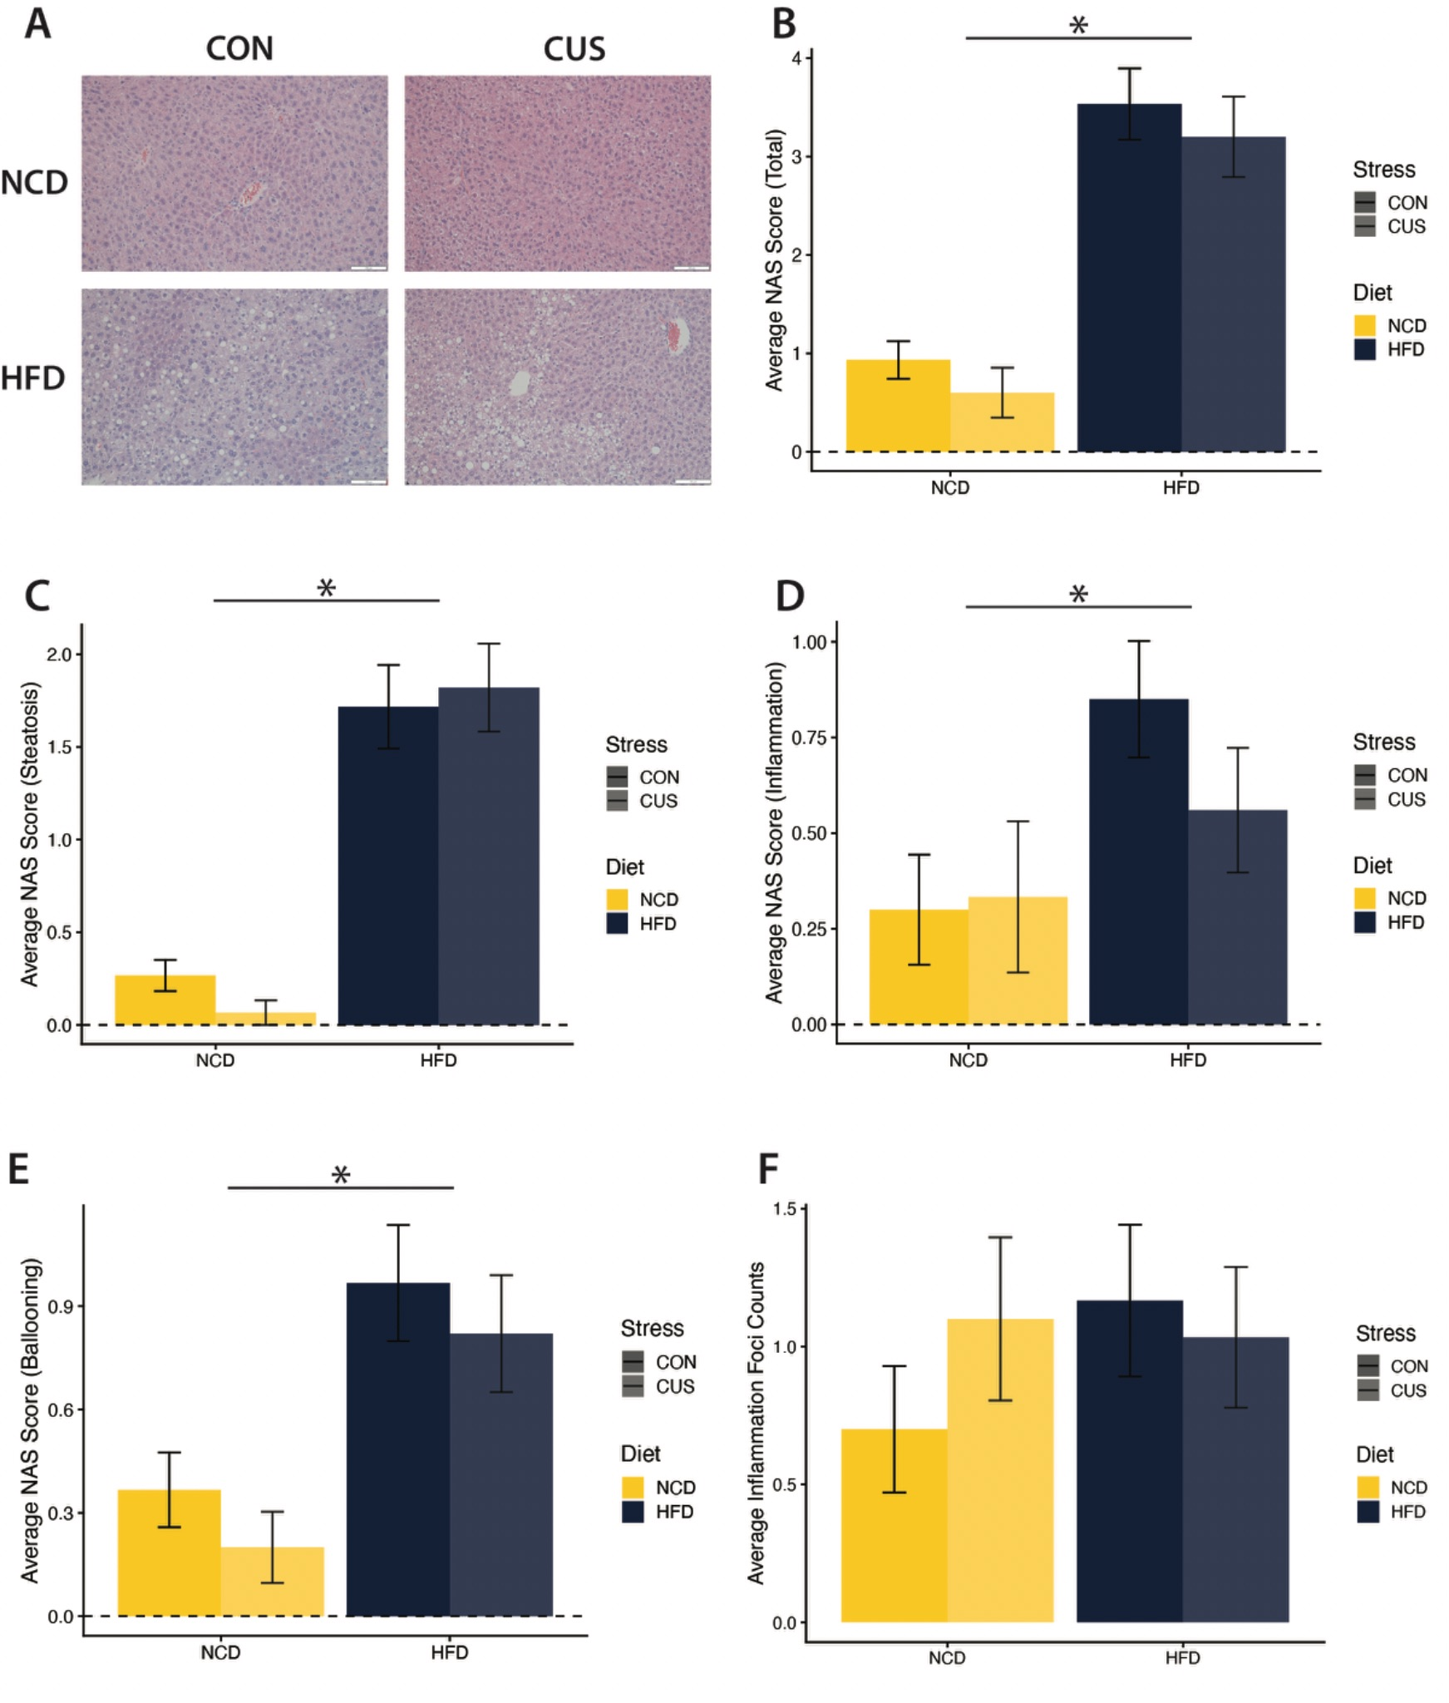

Figure 5. Effect of diet and stress on liver pathology. A. Representative hematoxylin and eosin (H&E)-stained liver sections. B. Total NAFLD Activity Score (NAS). C. Steatosis score. D. Inflammation score. E. Hepatocellular ballooning score. F. Inflammation foci counts. HFD: High-Fat Diet, NCD: Normal Chow Diet, CUS: Chronic Unpredictable Stress, CON: Control. Data are plotted as group means with SEM error bars. Asterisks indicate a significant effect of diet (HFD vs. NCD) from the corresponding regression model.

Chronic unpredictable stress altered 24-hour corticosterone rhythmicity
To determine whether diet-induced obesity and chronic unpredictable stress altered 24-hour corticosterone secretion, plasma corticosterone was measured across the light-dark cycle using automated blood sampling. Because corticosterone secretion is biologically rhythmic, we first used mixed-effects cosinor modeling to determine whether a significant 24-hour rhythmic component was present across the sampling period. Joint hypothesis testing of the sine and cosine terms confirmed significant rhythmicity (p < 0.001), indicating that these data contained a robust time-dependent pattern appropriate for waveform-based analyses.
We next used mixed-effects cosinor modeling to test whether diet, chronic unpredictable stress, or their interaction altered corticosterone waveform shape. Joint testing showed that diet alone did not significantly alter corticosterone rhythmicity (ns), whereas chronic unpredictable stress significantly altered corticosterone waveform shape (p = 0.0057). The diet x stress effect on waveform did not reach statistical significance, although a trend toward interaction was observed (p = 0.077, Figure 6A). Together, these findings indicate that the primary corticosterone effect of chronic stress in this cohort was a change in temporal pattern rather than a clear change in overall corticosterone exposure.
To further assess whether the stress-related waveform effect differed by diet group, stratified cosinor analyses were performed within NCD and HFD mice. In NCD mice, chronic unpredictable stress significantly altered corticosterone rhythmicity (p < 0.05), whereas in HFD mice the stress effect on waveform was not statistically significant (ns). Thus, the detectable stress-related alteration in corticosterone rhythmicity appeared to be driven primarily by the NCD group, while the corresponding effect in HFD mice was weaker and not statistically significant in this cohort. This pattern was also apparent in the observed corticosterone profiles, in which the difference between NCD-CUS and NCD-CON was more pronounced than the corresponding difference between HFD-CUS and HFD-CON (Figure 6B).
To investigate which rhythm descriptors were most affected, corticosterone summary parameters were analyzed using Kruskal-Wallis tests, pairwise comparisons, and gamma GLMs. Only selected parameters showed evidence of group differences, with the clearest signals observed for peak corticosterone and amplitude, whereas mesor, median, nadir, and AUC were not consistently different across analyses. These parameter-level findings were used to aid interpretation of the waveform-based results rather than to replace them, and suggest that chronic stress altered specific features of corticosterone rhythmicity without producing a robust overall shift in average corticosterone exposure.
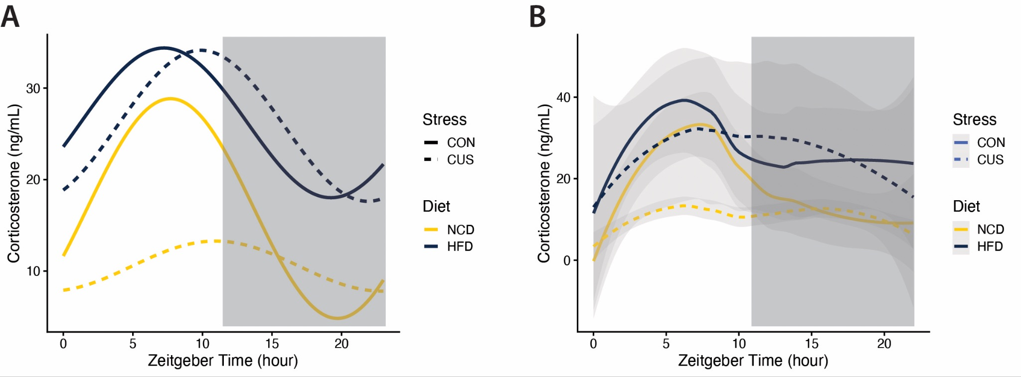
Figure 6. Observed and model-fitted 24-hour plasma corticosterone rhythms across diet and stress groups. A. Group-specific 24-hour corticosterone waveforms estimated from the full mixed-effects cosinor model. B. Observed plasma corticosterone concentrations across Zeitgeber time (ZT) in smoothed group-level trends with SEs in shades. HFD: High-Fat Diet, NCD: Normal Chow Diet, CUS: Chronic Unpredictable Stress, CON: Control. Data are plotted as mode-fitted group means.

Table 4. Corticosterone rhythm parameters and parameter-based statistical analyses across diet and stress groups. Values are presented as group means ± SE for corticosterone summary parameters calculated from the observed 24-hour corticosterone profiles. Mesor represents the arithmetic mean concentration across the 24-hour sampling period; peak, the maximum observed concentration; nadir, the minimum observed concentration; amplitude, half the difference between peak and nadir; acrophase, the observed timing of peak corticosterone concentration (ZT); and AUC, the 24-hour area under the curve. Additional rows summarize omnibus Kruskal-Wallis tests, prespecified pairwise comparisons, and gamma GLM results for each parameter (diet, stress, diet x stress). Prespecified pairwise comparisons of interest included HFD-CUS vs. HFD-CON, NCD-CUS vs. NCD-CON, HFD-CUS vs. NCD-CUS, and HFD-CON vs. NCD-CON.
HFD: High-Fat Diet, NCD: Normal Chow Diet, CUS: Chronic Unpredictable Stress, CON: Control.
Diet | Stress | Mesor | Peak | Acrophase | Nadir | Amplitude | AUC
HFD | CUS | 25.93 ± 15.75 | 47.52 ± 21.04 | 9.30 ± 1.51 | 13.42 ± 10.20 | 21.59 ± 6.80 | 591.61 ± 355.65
 | CON | 26.52 ± 10.95 | 65.60 ± 17.34 | 8.42 ± 1.60 | 13.10 ± 7.91 | 39.08 ± 7.88 | 595.46 ± 245.76
NCD | CUS | 10.54 ± 0.65 | 23.56 ± 1.50 | 7.50 ± 1.76 | 3.56 ± 0.63 | 13.02 ± 1.07 | 243.44 ± 14.50
 | CON | 16.83 ± 2.45 | 66.56 ± 15.51 | 7.25 ± 0.84 | 3.79 ± 0.61 | 49.72 ± 14.37 | 391.78 ± 57.56
Kruskal Wallis omnibus p-value |  | ns | p < 0.05 | ns | ns | p < 0.05 | ns
Pairwise Mann-Whitney p-value |  | p < 0.05 in NCD-CUS vs NCD-CON | p < 0.05 in NCD-CUS vs NCD-CON | ns | ns | p < 0.05 in HFD-CUS vs HFD-CON, NCD-CUS vs NCD-CON | p < 0.05 in NCD-CUS vs NCD-CON
GLM fit to a gamma distribution testing main and interacting effects |  | ns | p < 0.05 in Stress | ns | ns | p < 0.05 in Stress | ns

Endpoint serum glucose and insulin
To assess endpoint circulating metabolic measures, serum glucose and insulin were measured following a 4-hour fast. Serum glucose concentrations did not differ significantly by diet, stress, or their interaction (Supplementary Figure 2). Serum insulin was also measured; however, sample signals were uniformly low, with the highest estimated insulin concentration reaching only 24.33 μIU/mL. Correspondingly, sample optical densities were low overall (maximum O.D. = 0.140), indicating that most samples fell near the lower end of the standard curve. Although the standard curve performed appropriately, the assay did not provide sufficient sensitivity for robust group comparisons in these samples. Therefore, the insulin data were considered technically inconclusive and were not used to support biological interpretation of group differences.

Discussion
In this study, we investigated how chronic unpredictable stress interacts with diet-induced obesity to influence metabolic and behavioral outcomes in male C57BL/6J mice. We found that chronic unpredictable stress significantly reduced body weight after obesity had already been established, and this reduction was primarily driven by losses in lean mass rather than fat mass. Notably, these changes occurred with unchanged or even increased caloric intake, suggesting that stress altered energy balance through mechanisms independent of food consumption. In addition, both high-fat feeding and chronic stress increased anxiety-like behavior, whereas liver pathology was largely driven by diet rather than stress. Importantly, chronic unpredictable stress altered 24-hour corticosterone rhythmicity, with the clearest stress-related waveform disruptions observed in NCD mice and a weaker, non-significant effect in HFD mice. Together, these findings suggest that while some physiological effects of chronic stress (e.g. food intake, energy expenditure, lean mass loss) are augmented in HFD animals, this is not consistent with increased corticosterone levels in serum. Similarly, several effects of stress and diet (e.g. behavior and liver health) are not explained by differences in corticosterone levels.
One of the most notable findings of this study is that chronic unpredictable stress induced significant reductions in body weight after obesity had already been established. In both normal chow and high-fat diet groups, exposure to chronic stress resulted in progressive weight loss over the 21-day stress period. Importantly, the decline was greater in HFD mice than in NCD mice, indicating that pre-existing obesity may modify the physiological response to chronic stress. This pattern is broadly consistent with previous rodent studies showing that chronic stress can alter body weight trajectories, although the direction of change varies across dietary and experimental contexts. In some models, chronic stress suppresses body weight gain without necessarily producing overt weight loss, as reported in high-fat-fed mice exposed to chronic mild unpredictable stress and in mice subjected to chronic restraint stress (Hatton-Jones et al., 2022; Lippi, 2021; Tsuchimine et al., 2020). In other paradigms, chronic stress induces clear body weight loss, including in high-fat-fed mice exposed to chronic social defeat stress and in mice exposed to chronic restraint stress (Balsevich et al., 2014; Finger et al., 2011; J. Y. Jeong et al., 2013). Our findings are more consistent with the latter pattern, as stressed mice in both diet groups exhibited progressive weight loss rather than merely slower weight gain. Together, these observations suggest that chronic stress can not only blunt further weight gain, but also reverse the trajectory of body weight even after the obese phenotype has already been established.
Interestingly, the reduction in body weight observed in stressed mice was primarily driven by loss of lean mass rather than fat mass. Previous studies suggest that chronic stress can induce a catabolic phenotype characterized by reductions in lean body mass and skeletal muscle-related outcomes. For example, repeated stress has been reported to produce severe loss of lean body mass (Depke et al., 2008), chronic variable stress decreased lean body mass despite increased energy intake (Nikolic et al., 2023), and chronic stress has been shown to reduce body weight and skeletal muscle mass in mice (Fushimi et al., 2023). However, body composition responses are not fully uniform across models. In a chronic psychosocial stress model, stress reduced percent body fat and increased percent lean mass in both diet groups (Finger et al., 2011), suggesting that outcomes may differ depending on the paradigm and whether body composition is expressed as absolute mass or percentage. Mechanistically, glucocorticoids may contribute to this response by mobilizing energy stores while simultaneously diverting energy away from anabolic processes in tissues such as skeletal muscle (Swarbrick et al., 2021). This interpretation is also supported by studies in obesogenic and glucocorticoid-excess models, in which high-fat-fed animals exposed to corticosterone or dexamethasone exhibited greater reductions in lean or fat-free mass than lean controls (Auvinen et al., 2013; Gunder et al., 2020). Together, our findings suggest that in the setting of diet-induced obesity, chronic stress can promote a catabolic state in which lean tissue may be disproportionately affected, although the direction and magnitude of body composition changes may vary across experimental paradigms.
This distinction may also be relevant in humans, where weight loss in obesity is often interpreted as beneficial even though a substantial proportion may come from fat-free mass, including skeletal muscle. Recent reviews emphasize that loss of lean tissue during weight reduction may impair metabolic health and physical function and may increase the risk of sarcopenic obesity, underscoring the importance of distinguishing changes in total body weight from changes in body composition (Cava et al., 2017; Heymsfield et al., 2014; Stefanakis et al., 2024). This may be particularly important in the context of chronic stress, which in humans has been associated with dysregulated body composition and frailty- or osteosarcopenic-related phenotypes rather than uniformly favorable reductions in adiposity. From this perspective, stress-related weight loss in obesity may be clinically misleading if it masks concurrent losses of lean tissue (Stefanaki et al., 2018). One possible explanation is that chronic stress may shift skeletal muscle toward a catabolic state by both reducing protein synthesis and increasing protein degradation. Consistent with this idea, prior work suggests that chronic stress can suppress anabolic signaling through glucocorticoid-responsive pathways such as REDD1-mTORC1 while also activating FoxO-associated atrophy pathways, including Atrogin-1 and MuRF1 (Fushimi et al., 2023).
These stress-induced reductions in weight occurred despite similar or greater caloric intake among stressed mice, suggesting that reduced energy intake did not account for the observed weight loss. Direct evidence in diet-induced obesity models remains limited, but prior work suggests that chronic stress can alter body composition despite maintained or increased energy intake. For example, chronic variable stress has been reported to decrease lean body mass despite increased energy intake in male C57BL/6 mice (Nikolic et al., 2023). In contrast, in a chronic psychosocial stress model combining social defeat and overcrowding, stressed high-fat-fed mice exhibited reduced caloric intake together with body weight loss, with the hypophagic response being more pronounced in the high-fat diet group (Finger et al., 2011). These differences may reflect important variation in stress paradigm, as well as differences in food-intake measurement, since our study relied on weekly intake measurements and cage-averaged estimates for control mice. Nevertheless, these findings suggest that reduced food intake is not a universal explanation for stress-associated weight loss. In our model, the combination of lean mass loss and the absence of an obvious reduction in measured caloric intake suggests that chronic stress may have altered energy balance through mechanisms other than simple suppression of feeding. Possible contributors include increased energy expenditure, reduced caloric absorption, or altered nutrient utilization despite continued energy intake. Because neither energy expenditure, caloric absorption, nor precisely matched individual food intake was directly measured, the mechanisms underlying this response remain uncertain.
In behavioral testing, both high-fat diet and chronic stress independently increased anxiety-like behaviors in the open field test, with no significant effect from diet-stress interaction. This pattern is consistent with previous studies showing that high-fat feeding reduces center zone exploration in the open field and increases anxiety-like behavior in mice (Gainey et al., 2016), while chronic mild unpredictable stress similarly decreases time spent in the center and center entries in the open field test (Lippi, 2021). Evidence for a significant diet x stress interaction in OFT anxiety-like measures appears limited, and in one comparable study, the interaction between diet and stress was observed in spatial memory rather than in OFT outcomes (Lippi, 2021). Together, these findings suggest that both dietary obesity and chronic stress can independently shift exploratory behavior toward a phenotype with more anxiety-like behaviors, even when their combined effects are not statistically interactive.
More broadly, these findings are consistent with human studies suggesting that obesity is associated with increased anxiety-related burden and broader adverse psychological outcomes (Amiri & Behnezhad, 2019; Gariepy et al., 2010). Chronic stress and adverse life experiences have also been linked to increased risk of depression and other adverse mental health outcomes in humans (LeMoult et al., 2020; Satinsky et al., 2021). Against this background, our OFT findings suggest that both stress and obesity can bias behavior toward greater avoidance and reduced exploration. Although the present behavioral assays do not directly assess depression-like behavior, these results are consistent with the idea that both chronic stress and obesity may contribute to adverse affective outcomes. However, the absence of a significant diet x stress interaction indicates that, in this cohort, obesity did not clearly potentiate the behavioral effect of chronic stress.
In contrast, liver histological injury was largely driven by high fat feeding, while chronic stress did not significantly alter liver pathology. This pattern is consistent with prior studies showing that high-fat feeding alone is sufficient to induce hepatic injury in mice, including steatosis, hepatocyte ballooning, inflammation, and fibrosis (Eccleston et al., 2011; Velázquez et al., 2019). By comparison, the effect of chronic stress on liver pathology appears to be more context-dependent. In a NASH-inducing high-fat diet mouse model with chronic psychosocial stress, both stressed and non-stressed HFD-fed mice showed similar liver histology results (Czech et al., 2013). Notably, other studies have reported different effects from stress, suggesting that the hepatic effects of stress depend on the stress paradigm. For example, Liu et al. found that prolonged chronic stress induced hepatic triglyceride and cholesterol accumulation in normal diet mice, together with microvesicular steatosis, lobular inflammation, and ballooning (Y.-Z. Liu et al., 2014). In contrast, Lee et al. reported that intermittent restraint stress attenuated HFD-induced hepatic steatosis and partial inflammation, which they linked to sympathetic activation (Lee et al., 2019). These discrepancies likely reflect major design differences across studies. In Liu et al., chronic stress was applied for 12 weeks and served largely as a primary driver of liver injury, whereas in our study mice first developed diet-induced obesity before undergoing a 21-day chronic unpredictable stress protocol (Y.-Z. Liu et al., 2014). Lee et al. also used a predictable intermittent restraint paradigm, which is physiologically distinct from chronic unpredictable stress and may evoke different metabolic adaptations (Lee et al., 2019). Together, these findings support the interpretation that, in our model, high-fat diet was the dominant driver of liver histological injury, whereas chronic stress did not produce an additional detectable worsening of liver pathology.
In the present study, conventional analyses of plasma corticosterone did not detect significant effects of diet, stress, or their interaction on overall corticosterone exposure or standard summary measures like mesor, peak, minimum, and 24-hour area under the curve. Prior studies evaluating conventional plasma corticosterone in high-fat diet and chronic stress models have mixed findings. Several studies were broadly consistent with our results and found no significant diet or chronic stress effects on conventional plasma corticosterone measures (Finger et al., 2011; Michel et al., 2005). Notably, however, Finger et al. observed a difference after an additional acute stimulus, with chronically stressed mice showing higher corticosterone 24 hours after the forced swim test (Finger et al., 2011). Earlier work by Armario et al. likewise showed that basal corticosterone remained unchanged in chow-fed mice after chronic stress even though corticosterone responses to acute restraint were enhanced (Armario et al., 1985). Together, these studies suggest that it is important to distinguish between basal corticosterone secretion and corticosterone responsiveness to a subsequent acute stressor. Thus, the absence of significant group differences in our conventional summary measures does not necessarily indicate that chronic stress failed to alter HPA-axis function; rather, under our experimental conditions and in the absence of an additional acute stimulus, diet-induced obesity and chronic unpredictable stress did not produce detectable differences in overall plasma corticosterone exposure. In contrast, Tsai et al. reported that HFD-fed mice had higher plasma corticosterone than chow-fed controls, although social defeat stress did not further increase corticosterone beyond the diet effect (Tsai et al., 2018), suggesting that conventional plasma corticosterone may be highly sensitive to model design, stress modality, and sampling context.
In contrast to conventional analyses, cosinor modeling indicated that the major corticosterone effect in our study was a stress-related alteration in 24-hour rhythmicity rather than a detectable difference in overall circulating corticosterone exposure. In particular, chronic unpredictable stress in NCD mice was associated with a lower fitted mesor, reduced amplitude, and a delayed acrophase, indicating a flattened and phase-delayed corticosterone rhythm, where the effect from stress was not significant in HFD mice. Although directly comparable plasma corticosterone cosinor studies in diet-induced obese mouse models with chronic stress remain limited, prior work supports the idea that corticosterone dysregulation may be expressed as altered circadian rhythm. Appiakannan et al. found that after 8 weeks of HFD, baseline corticosterone levels were of similar magnitude to chow-fed controls but more variable, rendering arrhythmic daily fluctuations; they further showed that acute restraint stress exaggerated corticosterone responses, particularly during the early active phase (Appiakannan et al., 2019). Similarly, Teeple et al. found that high-fat feeding was associated with elevated basal corticosterone, attenuated circadian rhythms, reduced amplitude, and a shifted acrophase, although those findings were derived from hair and fecal corticosterone rather than plasma (Teeple et al., 2023). Taken together, these studies suggest that chronic stress- or diet-related HPA-axis disruption may be more evident in the temporal rhythm of corticosterone secretion.
An important strength of this work is its balanced design, which integrated metabolic, behavioral, physiological, histological, and endocrine outcomes within the same cohort of mice. This allowed the effects of diet-induced obesity and chronic unpredictable stress to be evaluated across multiple physiological systems rather than in isolation. The experimental design also strengthened interpretation by establishing obesity before stress exposure, making the model more relevant for examining stress responses in the setting of pre-existing obesity. In addition, the use of male C57BL/6J mice provided a genetically uniform background that reduced between-subject variability and improved experimental control, which was advantageous for detecting diet- and stress-related effects. Repeated automated blood sampling across the 24-hour light-dark cycle further strengthened the study by allowing corticosterone dynamics to be assessed in a minimally disruptive manner, and by enabling waveform-based analyses that captured rhythmic features not evident from conventional summary measures alone. Mouse models also remain a particularly useful platform for this type of work because diet, stress exposure, and sampling conditions can be tightly controlled in ways that are not feasible in human studies.
At the same time, several considerations help frame the interpretation of these findings and point to productive directions for future work. Food intake in control mice was estimated at the cage level based on food disappearance, which limited precision for detecting subtle individual-level differences; however, these measurements were still sufficient to identify meaningful diet- and stress-related patterns in energy intake and therefore provided useful context for interpreting the body weight and body composition data. Estimated energy expenditure was derived indirectly from intake and body composition changes rather than direct measurements, but these findings nevertheless provide an informative starting point and suggest that future studies using more precise approaches such as indirect calorimetry could further clarify how chronic stress alters energy balance in obese mice. Endpoint glucose and insulin measures were less informative than anticipated, because terminal sampling was performed in the morning after the nocturnal feeding period, when mice had likely consumed substantial food overnight; under these conditions, a 4-hour fast may have provided limited contrast for detecting group differences in serum glucose. In addition, the insulin assay lacked sufficient sensitivity for robust group comparisons. The use of a single sex and a single inbred strain also narrows generalizability, but it reduced background variability and improved experimental control in this initial study; future work can build on this framework by testing whether similar effects are present in females or across other genetic backgrounds. More broadly, although mouse models do not fully recapitulate human physiology, they were well suited for the present study because they allowed controlled manipulation of diet and stress exposure while minimizing environmental heterogeneity. Finally, while the present findings identify clear metabolic, behavioral, liver, and corticosterone-rhythmic phenotypes, they do not yet define the underlying mechanisms. These results therefore provide a foundation for future studies at the molecular level, including analyses of gene expression and other pathways involved in HPA-axis regulation, metabolism, and tissue-specific stress responses.

In conclusion, we performed behavioral, metabolic and endocrine evaluation of how diet modifies the response to an unpredictable chronic stress exposure, identifying some cases where these exposures appear to be additive (e.g. anxiety-like behaviors) while some effects are consistent with synergism between obesity/diet and stress (e.g. food intake, lean mass losses). Given the very high prevalence of both obesity and chronic stress in society, this work informs our understanding of risks for depression, metabolic disease and sarcopenic obesity.

Acknowledgement
This work was supported by a Rackham Research Grant and utilized the resources of the MMPC-Live core facility, funded by NIH Grant U2CDK135066. I would like to express my sincere gratitude to everyone who contributed to this project and supported me throughout this work.
First and foremost, I am deeply grateful to my mentor, Dr. Dave Bridges, whose influence on my growth has extended far beyond research. He has been not only a scientific mentor, but also a source of guidance and encouragement in both my academic and personal development. From shaping this project to offering extraordinary support throughout the PhD application process, he has helped me become a more confident, resilient, and capable person. Meeting Dave during my master’s training has been one of the greatest privileges in this chapter of my life, and I feel truly honored to have learned from his mentorship.
I would also like to thank the members of the Bridges Lab for their support, thoughtful discussions, and encouragement throughout this process.
I am especially thankful to the University of Michigan Mouse Metabolic Phenotyping Centers (MMPC) for their expert technical assistance with carotid artery surgery, Culex automated blood sampling, and behavioral testing. Their contributions were essential to the successful completion of this study. I also thank Raktim Mukherjee from the Carey Lumeng Lab for taking the images of the liver histology slides.
I am grateful to my committee members, Dr. Natalie Tronson, Dr. Kristen Schuh, Dr. Edward Ruiz-Narvaez, and Dr. Kendrin Sonneville, for their guidance and valuable feedback throughout this project.
Finally, I am deeply grateful to my parents. Although we have been separated by an ocean and live in different time zones, they have remained a constant source of support and encouragement throughout this journey.
I am also deeply thankful for my friends, who have been my family to me while I have been far from home. They have been my companions, my teammates, and my steady source of strength and support. We have relied on one another and moved forward together through the challenges of this journey.

References
R Core Team (2024). _R: A Language and Environment for Statistical Computing_. R
Foundation for Statistical Computing, Vienna, Austria. <https://www.R-project.org/>.
Douglas Bates, Martin Maechler, Ben Bolker, Steve Walker (2015). Fitting Linear Mixed-Effects
Models Using lme4. Journal of Statistical Software, 67(1), 1-48. doi:10.18637/jss.v067.i01.
Amiri, S., & Behnezhad, S. (2019). Obesity and anxiety symptoms: A systematic review and meta-analysis. Neuropsychiatrie, 33(2), 72–89. https://doi.org/10.1007/s40211-019-0302-9
Appiakannan, H. S., Kestyus, D. R., & Weber, E. T. (2019). Effects of high fat diet and chronic circadian challenge on glucocorticoid regulation in C57BL/6J mice. Physiology & Behavior, 204, 100–105. https://doi.org/10.1016/j.physbeh.2019.01.014
Armario, A., Restrepo, C., Castellanos, J. M., & Balasch, J. (1985). Dissociation between adrenocorticotropin and corticosterone responses to restraint after previous chronic exposure to stress. Life Sciences, 36(22), 2085–2092. https://doi.org/10.1016/0024-3205(85)90304-2
Athanassi, A., Breton, M., Chalençon, L., Brunelin, J., Didier, A., Bath, K., & Mandairon, N. (2023). Chronic unpredictable mild stress alters odor hedonics and adult olfactory neurogenesis in mice. Frontiers in Neuroscience, 17, 1224941. https://doi.org/10.3389/fnins.2023.1224941
Auvinen, H. E., Coomans, C. P., Boon, M. R., Romijn, J. A., Biermasz, N. R., Meijer, O. C., Havekes, L. M., Smit, J. W. A., Rensen, P. C. N., & Pereira, A. M. (2013). Glucocorticoid excess induces long-lasting changes in body composition in male C57Bl/6J mice only with high-fat diet. Physiological Reports, 1(5), e00103. https://doi.org/10.1002/phy2.103
Balsevich, G., Uribe, A., Wagner, K. V., Hartmann, J., Santarelli, S., Labermaier, C., & Schmidt, M. V. (2014). Interplay between diet-induced obesity and chronic stress in mice: Potential role of FKBP51. Journal of Endocrinology, 222(1), 15–26. https://doi.org/10.1530/JOE-14-0129
Buchenauer, T., Behrendt, P., Bode, F. J., Horn, R., Brabant, G., Stephan, M., & Nave, H. (2009). Diet-induced obesity alters behavior as well as serum levels of corticosterone in F344 rats. Physiology & Behavior, 98(5), 563–569. https://doi.org/10.1016/j.physbeh.2009.09.003
Cava, E., Yeat, N. C., & Mittendorfer, B. (2017). Preserving Healthy Muscle during Weight Loss123. Advances in Nutrition, 8(3), 511–519. https://doi.org/10.3945/an.116.014506
Cuevas, A. G., Chen, R., Thurber, K. A., Slopen, N., & Williams, D. R. (2019). Psychosocial Stress and Overweight and Obesity: Findings From the Chicago Community Adult Health Study. Annals of Behavioral Medicine, 53(11), NP-NP. https://doi.org/10.1093/abm/kaz008
Czech, B., Neumann, I. D., Müller, M., Reber, S. O., & Hellerbrand, C. (2013). Effect of chronic psychosocial stress on nonalcoholic steatohepatitis in mice. International Journal of Clinical and Experimental Pathology, 6(8), 1585–1593.
Depke, M., Fusch, G., Domanska, G., Geffers, R., Völker, U., Schuett, C., & Kiank, C. (2008). Hypermetabolic Syndrome as a Consequence of Repeated Psychological Stress in Mice. Endocrinology, 149(6), 2714–2723. https://doi.org/10.1210/en.2008-0038
Eccleston, H. B., Andringa, K. K., Betancourt, A. M., King, A. L., Mantena, S. K., Swain, T. M., Tinsley, H. N., Nolte, R. N., Nagy, T. R., Abrams, G. A., & Bailey, S. M. (2011). Chronic Exposure to a High-Fat Diet Induces Hepatic Steatosis, Impairs Nitric Oxide Bioavailability, and Modifies the Mitochondrial Proteome in Mice. Antioxidants & Redox Signaling, 15(2), 447–459. https://doi.org/10.1089/ars.2010.3395
Engin, A. (2024). The Definition and Prevalence of Obesity and Metabolic Syndrome: Correlative Clinical Evaluation Based on Phenotypes. In A. B. ENGIN & A. ENGIN (Eds.), Obesity and Lipotoxicity (pp. 1–25). Springer International Publishing. https://doi.org/10.1007/978-3-031-63657-8_1
Finger, B. C., Dinan, T. G., & Cryan, J. F. (2011). High-fat diet selectively protects against the effects of chronic social stress in the mouse. Neuroscience, 192, 351–360. https://doi.org/10.1016/j.neuroscience.2011.06.072
Fushimi, S., Nohno, T., & Katsuyama, H. (2023). Chronic Stress Induces Type 2b Skeletal Muscle Atrophy via the Inhibition of mTORC1 Signaling in Mice. Medical Sciences, 11(1), 19. https://doi.org/10.3390/medsci11010019
Gainey, S. J., Kwakwa, K. A., Bray, J. K., Pillote, M. M., Tir, V. L., Towers, A. E., & Freund, G. G. (2016). Short-Term High-Fat Diet (HFD) Induced Anxiety-Like Behaviors and Cognitive Impairment Are Improved with Treatment by Glyburide. Frontiers in Behavioral Neuroscience, 10, 156. https://doi.org/10.3389/fnbeh.2016.00156
Gariepy, G., Nitka, D., & Schmitz, N. (2010). The association between obesity and anxiety disorders in the population: A systematic review and meta-analysis. International Journal of Obesity, 34(3), 407–419. https://doi.org/10.1038/ijo.2009.252
Gunder, L. C., Harvey, I., Redd, J. R., Davis, C. S., AL-Tamimi, A., Brooks, S. V., & Bridges, D. (2020). Obesity Augments Glucocorticoid-Dependent Muscle Atrophy in Male C57BL/6J Mice. Biomedicines, 8(10), Article 10. https://doi.org/10.3390/biomedicines8100420
Harvey, I., Stephenson, E. J., Redd, J. R., Tran, Q. T., Hochberg, I., Qi, N., & Bridges, D. (2018). Glucocorticoid-Induced Metabolic Disturbances Are Exacerbated in Obese Male Mice. Endocrinology, 159(6), 2275–2287. https://doi.org/10.1210/en.2018-00147
Hatton-Jones, K., Cox, A. J., Peart, J. N., Headrick, J. P., & du Toit, E. F. (2022). Stress-induced body weight loss and improvements in cardiometabolic risk factors do not translate to improved myocardial ischemic tolerance in western diet-fed mice. Physiological Reports, 10(2), e15170. https://doi.org/10.14814/phy2.15170
Heymsfield, S. B., Cristina Gonzalez, M. C., Shen, W., Redman, L., & Thomas, D. (2014). Weight Loss Composition is One-Fourth Fat-Free Mass: A Critical Review and Critique of This Widely Cited Rule. Obesity Reviews : An Official Journal of the International Association for the Study of Obesity, 15(4), 310–321. https://doi.org/10.1111/obr.12143
Incollingo Rodriguez, A. C., Epel, E. S., White, M. L., Standen, E. C., Seckl, J. R., & Tomiyama, A. J. (2015). Hypothalamic-pituitary-adrenal axis dysregulation and cortisol activity in obesity: A systematic review. Psychoneuroendocrinology, 62, 301–318. https://doi.org/10.1016/j.psyneuen.2015.08.014
Jeong, B.-K., Choi, W.-I., Choi, W., Moon, J., Lee, W. H., Choi, C., Choi, I. Y., Lee, S.-H., Kim, J. K., Ju, Y. S., Kim, P., Moon, Y.-A., Park, J. Y., & Kim, H. (2024). A male mouse model for metabolic dysfunction-associated steatotic liver disease and hepatocellular carcinoma. Nature Communications, 15, 6506. https://doi.org/10.1038/s41467-024-50660-y
Jeong, J. Y., Lee, D. H., & Kang, S. S. (2013). Effects of Chronic Restraint Stress on Body Weight, Food Intake, and Hypothalamic Gene Expressions in Mice. Endocrinology and Metabolism, 28(4), 288–296. https://doi.org/10.3803/EnM.2013.28.4.288
Karimkhanloo, H., Keenan, S. N., Bayliss, J., De Nardo, W., Miotto, P. M., Devereux, C. J., Nie, S., Williamson, N. A., Ryan, A., Watt, M. J., & Montgomery, M. K. (2023). Mouse strain-dependent variation in metabolic associated fatty liver disease (MAFLD): A comprehensive resource tool for pre-clinical studies. Scientific Reports, 13, 4711. https://doi.org/10.1038/s41598-023-32037-1
Lee, S. B., Kim, H. G., Lee, J. S., Kim, W. Y., Lee, M. M., Kim, Y. H., Lee, J. O., Kim, H. S., & Son, C. G. (2019). Intermittent restraint-induced sympathetic activation attenuates hepatic steatosis and inflammation in a high-fat diet-fed mouse model. American Journal of Physiology-Gastrointestinal and Liver Physiology, 317(6), G811–G823. https://doi.org/10.1152/ajpgi.00047.2019
LeMoult, J., Humphreys, K. L., Tracy, A., Hoffmeister, J.-A., Ip, E., & Gotlib, I. H. (2020). Meta-Analysis: Exposure to Early Life Stress and Risk for Depression in Childhood and Adolescence. Journal of the American Academy of Child and Adolescent Psychiatry, 59(7), 842–855. https://doi.org/10.1016/j.jaac.2019.10.011
Liang, W., Menke, A. L., Driessen, A., Koek, G. H., Lindeman, J. H., Stoop, R., Havekes, L. M., Kleemann, R., & van den Hoek, A. M. (2014). Establishment of a General NAFLD Scoring System for Rodent Models and Comparison to Human Liver Pathology. PLoS ONE, 9(12), e115922. https://doi.org/10.1371/journal.pone.0115922
Lippi, S. L. P. (2021). Chronic Mild Unpredictable Stress and High-Fat Diet Given during Adolescence Impact Both Cognitive and Noncognitive Behaviors in Young Adult Mice. Brain Sciences, 11(2). https://doi.org/10.3390/brainsci11020260
Liu, X.-J., Duan, N.-N., Liu, C., Niu, C., Liu, X.-P., & Wu, J. (2018). Characterization of a murine nonalcoholic steatohepatitis model induced by high fat high calorie diet plus fructose and glucose in drinking water. Laboratory Investigation, 98(9), 1184–1199. https://doi.org/10.1038/s41374-018-0074-z
Liu, Y.-Z., Chen, J.-K., Zhang, Y., Wang, X., Qu, S., & Jiang, C.-L. (2014). Chronic stress induces steatohepatitis while decreases visceral fat mass in mice. BMC Gastroenterology, 14, 106. https://doi.org/10.1186/1471-230X-14-106
Livingstone, D. E. W., Jones, G. C., Smith, K., Jamieson, P. M., Andrew, R., Kenyon, C. J., & Walker, B. R. (2000). Understanding the Role of Glucocorticoids in Obesity: Tissue-Specific Alterations of Corticosterone Metabolism in Obese Zucker Rats1. Endocrinology, 141(2), 560–563. https://doi.org/10.1210/endo.141.2.7297
Mao, M., Deng, Y., Wang, L., Zhao, G., Qi, R., Gong, H., Shen, T., Xu, Y., Liu, D., & Chen, B. (2023). Chronic unpredictable mild stress promotes atherosclerosis via adipose tissue dysfunction in ApoE^{-/-} mice. PeerJ, 11, e16029. https://doi.org/10.7717/peerj.16029
Michel, C., Duclos, M., Cabanac, M., & Richard, D. (2005). Chronic stress reduces body fat content in both obesity-prone and obesity-resistant strains of mice. Hormones and Behavior, 48(2), 172–179. https://doi.org/10.1016/j.yhbeh.2005.02.004
Nikolic, A., Fahlbusch, P., Wahlers, N., Riffelmann, N.-K., Jacob, S., Hartwig, S., Kettel, U., Dille, M., Al-Hasani, H., Kotzka, J., & Knebel, B. (2023). Chronic stress targets mitochondrial respiratory efficiency in the skeletal muscle of C57BL/6 mice. Cellular and Molecular Life Sciences: CMLS, 80(4), 108. https://doi.org/10.1007/s00018-023-04761-4
Ravussin, Y., Gutman, R., LeDuc, C. A., & Leibel, R. L. (2013). Estimating Energy Expenditure in mice using an Energy Balance Technique. International Journal of Obesity (2005), 37(3), 399–403. https://doi.org/10.1038/ijo.2012.105
Russell, G., & Lightman, S. (2019). The human stress response. Nature Reviews Endocrinology, 15(9), 525–534. https://doi.org/10.1038/s41574-019-0228-0
Sáenz De Miera, C., Feng, J., Elias, C. F., & Qi, N. (2023). Remote Neuronal Activation Coupled with Automated Blood Sampling to Induce and Measure Circulating Luteinizing Hormone in Mice. Journal of Visualized Experiments, (198), 65875. https://doi.org/10.3791/65875
Satinsky, E. N., Kakuhikire, B., Baguma, C., Rasmussen, J. D., Ashaba, S., Cooper-Vince, C. E., Perkins, J. M., Kiconco, A., Namara, E. B., Bangsberg, D. R., & Tsai, A. C. (2021). Adverse childhood experiences, adult depression, and suicidal ideation in rural Uganda: A cross-sectional, population-based study. PLoS Medicine, 18(5), e1003642. https://doi.org/10.1371/journal.pmed.1003642
Selvarani, R., Nguyen, H. M., Pazhanivel, N., Raman, M., Lee, S., Wolf, R. F., Deepa, S. S., & Richardson, A. (2025). The role of inflammation induced by necroptosis in the development of fibrosis and liver cancer in novel knockin mouse models fed a western diet. GeroScience, 47(3), 2973–2994. https://doi.org/10.1007/s11357-024-01418-3
Stefanaki, C., Pervanidou, P., Boschiero, D., & Chrousos, G. P. (2018). Chronic stress and body composition disorders: Implications for health and disease. Hormones, 17(1), 33–43. https://doi.org/10.1007/s42000-018-0023-7
Stefanakis, K., Kokkorakis, M., & Mantzoros, C. S. (2024). The impact of weight loss on fat-free mass, muscle, bone and hematopoiesis health: Implications for emerging pharmacotherapies aiming at fat reduction and lean mass preservation. Metabolism - Clinical and Experimental, 161. https://doi.org/10.1016/j.metabol.2024.156057
Swarbrick, M., Zhou, H., & Seibel, M. (2021). MECHANISMS IN ENDOCRINOLOGY: Local and systemic effects of glucocorticoids on metabolism: new lessons from animal models. European Journal of Endocrinology, 185(5), R113–R129. https://doi.org/10.1530/EJE-21-0553
Teeple, K., Rajput, P., Gonzalez, M., Han-Hallett, Y., Fernández-Juricic, E., & Casey, T. (2023). High fat diet induces obesity, alters eating pattern and disrupts corticosterone circadian rhythms in female ICR mice. PLOS ONE, 18(1), e0279209. https://doi.org/10.1371/journal.pone.0279209
Tomiyama, A. J. (2018). Stress and Obesity.
Tsai, S.-F., Wu, H.-T., Chen, P.-C., Chen, Y.-W., Yu, M., Tzeng, S.-F., Wu, P.-H., Chen, P.-S., & Kuo, Y.-M. (2018). Stress Aggravates High-Fat-Diet-Induced Insulin Resistance via a Mechanism That Involves the Amygdala and Is Associated with Changes in Neuroplasticity. Neuroendocrinology, 107(2), 147–157. https://doi.org/10.1159/000491018
Tsuchimine, S., Matsuno, H., O’Hashi, K., Chiba, S., Yoshimura, A., Kunugi, H., & Sohya, K. (2020). Comparison of physiological and behavioral responses to chronic restraint stress between C57BL/6J and BALB/c mice. Biochemical and Biophysical Research Communications, 525(1), 33–38. https://doi.org/10.1016/j.bbrc.2020.02.073
Velázquez, K. T., Enos, R. T., Bader, J. E., Sougiannis, A. T., Carson, M. S., Chatzistamou, I., Carson, J. A., Nagarkatti, P. S., Nagarkatti, M., & Murphy, E. A. (2019). Prolonged high-fat-diet feeding promotes non-alcoholic fatty liver disease and alters gut microbiota in mice. World Journal of Hepatology, 11(8), 619–637. https://doi.org/10.4254/wjh.v11.i8.619
Yang, M., Qi, X., Li, N., Kaifi, J. T., Chen, S., Wheeler, A. A., Kimchi, E. T., Ericsson, A. C., Rector, R. S., Staveley-O’Carroll, K. F., & Li, G. (2023). Western diet contributes to the pathogenesis of non-alcoholic steatohepatitis in male mice via remodeling gut microbiota and increasing production of 2-oleoylglycerol. Nature Communications, 14, 228. https://doi.org/10.1038/s41467-023-35861-1

Supplemental Figures
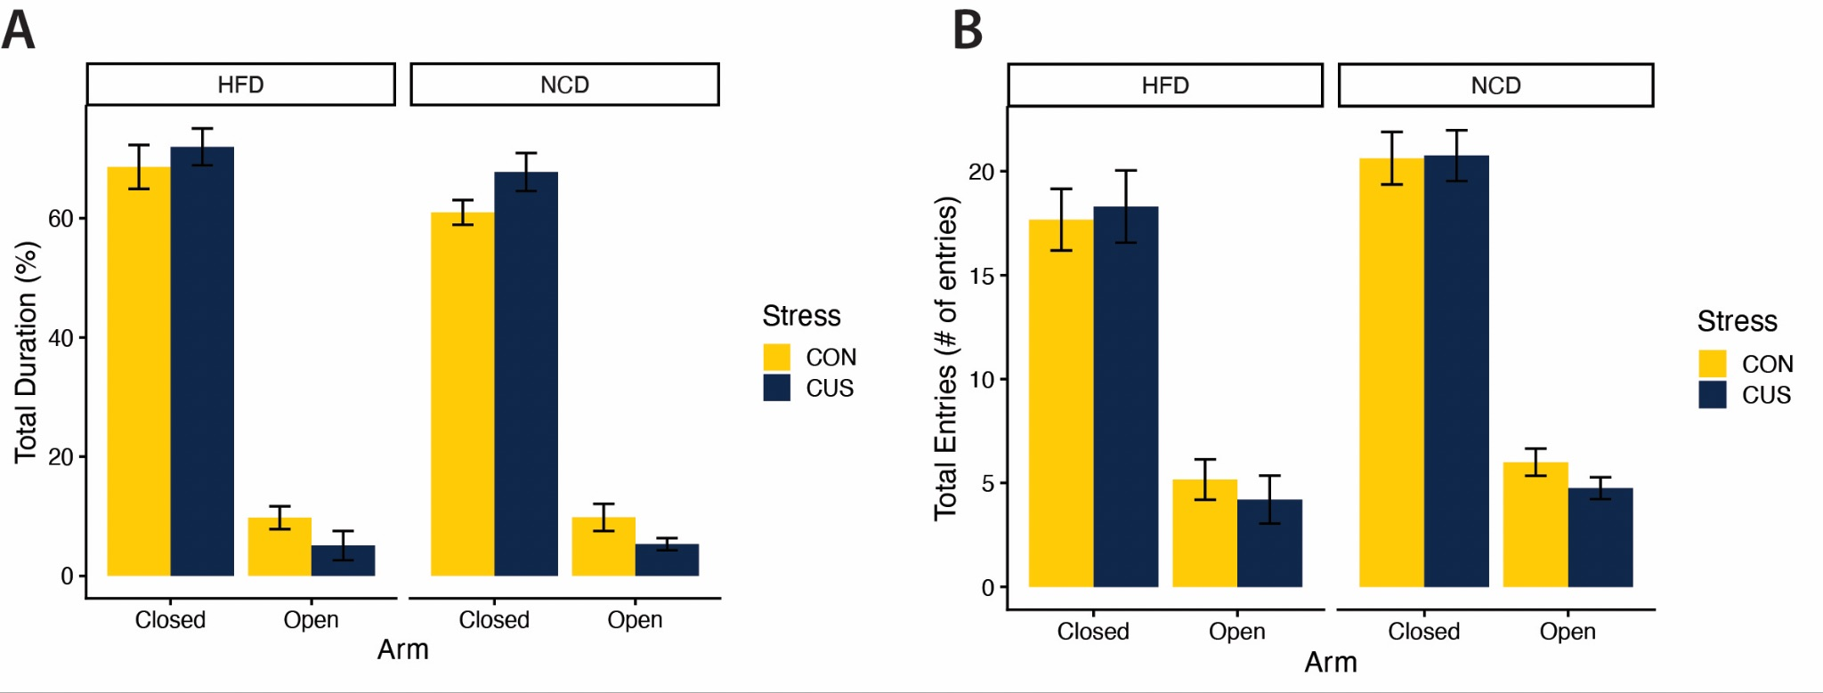
Supplemental Figure 1. Elevated Plus Maze performance was not significantly altered by high-fat diet or chronic unpredictable stress. A. Percentage of total test duration spent in the closed and open arms of the Elevated Plus Maze (EPM). B. Total number of entries into the closed and open arms of the EPM. HFD: High-Fat Diet, NCD: Normal Chow Diet, CUS: Chronic Unpredictable Stress, CON: Control. Data are plotted as group means with SEM error bars.

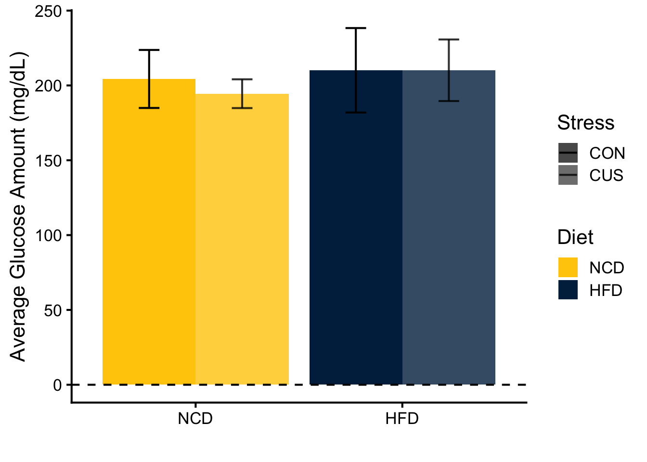
Supplemental Figure 2. Endpoint fasting serum glucose concentrations by diet and stress group. HFD: High- Fat Diet, NCD: Normal Chow Diet, CUS: Chronic Unpredictable Stress, CON: Control. Data are plotted as group means with SEM error bars.

